The Generic Statistical Information Model
(Version 0.3, March 2012)

Executive Summary

1. The Generic Statistical Information Model (GSIM) is a reference framework of information objects, which enables generic descriptions of data and metadata definition, management, and use throughout the statistical production process.

2. The GSIM is needed because statistical organisations are confronted with shrinking budgets on the one hand, and pressure to produce more data in quicker and more flexible ways on the other. As a common reference framework for information objects, the GSIM will facilitate the modernisation of statistical production by improving communication at different levels:

- Between the different roles in statistical production (statisticians, methodologists and information technology experts);
- Between the statistical subject matter domains;
- Between statistical organisations at the national and international levels.

3. The GSIM is designed to be complementary to other international standards, particularly the Generic Statistical Business Process Model (GSBPM). It should not be seen in isolation, and should be used in combination with other standards.

4. Implementation of the GSIM in combination with the GSBPM and common methods integrated in standardised components in a more modular production system will:

- Create an environment prepared for reuse and sharing of methods, components and processes.
- Offer the opportunity to implement rule based process control, thus minimising human intervention in the production process.
- Generate economies of scale within and between statistical organisations through common development of tools and methods.

5. Like the GSBPM, the GSIM can be seen as a layered model, identifying a limited number of high-level information objects in the top levels, and adding more detailed objects in lower levels. The information objects are organized in four groups on level 1:

- The statistical service group provides objects that are needed for external communication: information request, business case and statistical products.
- The conceptual group consists of categorized repositories of common statistical information objects: statistical unit, population, variable and classification.
- The structural group consists of the information objects that identify and describe the data. These objects are the metadata needed to identify, use and process data. It contains the following common data objects in increasing complexity: data element, data set, data series and composite data set.
- The production group is composed of production elements that are distinguished according to their functions in the modelling and design of statistical production systems: component, rule and schedule.

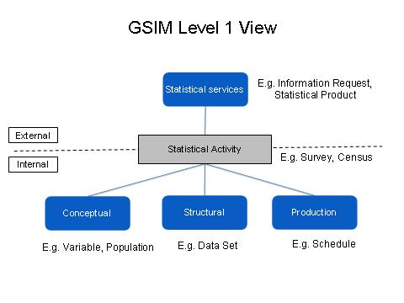
6. Level two information objects have been identified and defined, and it is expected that future versions of the GSIM will include at least one more level. However a point will be reached, as for the GSBPM, where the level of detail starts to become specific to certain contexts rather than generic across organisations and countries. This will be the level at which to stop the elaboration of the GSIM, and focus on implementations.

I. Background

7. In June 2010 an informal workgroup on stronger collaboration on Statistical Information Management Systems, meeting on the margins of the OECD Committee on Statistics, identified an essential role for a Generic Statistical Information Model (GSIM). This would provide a consistent reference model for defining the information objects required to drive statistical production processes, and the output from these processes.

8. This work was taken forward under the OCMIMF (Operationalize a Common Metadata/Information Management Framework) project, by representatives of the national statistical organisations of Australia, Canada, New Zealand, Norway, Sweden and the United Kingdom. A version 0.1 of the GSIM Common Reference Model was released by this group for wider comment in June 2011.

9. During the same period, the Conference of European Statisticians created a High Level Group for Strategic Developments in Business Architecture in Statistics (HLG-BAS), to oversee and coordinate various international activities related to the modernisation of statistical production. The HLG-BAS developed a vision paper, which was endorsed by the Conference of European Statisticians in June 2011. This vision identified four cornerstones for the modernisation of statistical production: harmonised methodology; standardised technology; the Generic Statistical Business Process Model (GSBPM) and the GSIM. As the GSIM was the least developed of these cornerstones, development work was accelerated under the sponsorship of the HLG-BAS.

10. This version of the GSIM documentation reflects the position at the end of a “sprint” session held in Ljubljana, Slovenia in February / March 2012. It is expected that it will pass through several iterations of feedback and re-drafting before it is considered mature enough to be endorsed as ready for operational use.

II. What is the GSIM?

The Generic Statistical Information Model is a reference framework of information objects, which enables generic descriptions of data and metadata definition, management, and use throughout the statistical production process.

11. The GSIM should therefore be seen as complementary to other international standards, and particularly the GSBPM. These relationships are further explored in Section 4, but it is important to state from the outset that the GSIM should not be seen in isolation. It is designed to be used in combination with other standards.

12. Like the GSBPM, the GSIM can be seen as a layered model, identifying a limited number of high-level information objects in the top levels, and adding more detailed objects in lower levels.

13. The information objects are organized in four groups on level 1: statistical services; conceptual; structural; and production. These groups are defined as follows:

- The statistical service group provides objects that are needed for external communication, in the process order: information request, business case and statistical products.
- The conceptual group consists of categorized repositories of common statistical information objects: statistical unit, population, variable and classification.
- The structural group consists of the information objects that identify and describe the data. These objects are metadata needed to identify, use and process data. Structural metadata must be associated with statistical data, otherwise it becomes impossible to identify, retrieve and control the data. It contains the following common data objects in order of increasing complexity: data element, data set, data series and composite data set.
- The production group is composed of production elements that are distinguished according to their functions in the modelling and design of statistical production systems: component, rule and schedule.
14. On level 2 the objects are arranged according to the level 1 groups. Definitions of the level 2 objects are presented in Annex A.

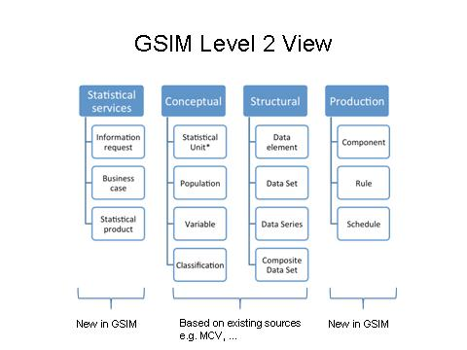
* The term “statistical unit” is used to cover all units used in the production of statistics. It is recognised that this may not be the best term for this definition.

15. Level 2 has been organized with the intention to facilitate the use of the GSIM in practice. In particular, some general remarks seem worthwhile.

- There are certain hierarchical relationships or logical overlaps among the object categories. For instance, within the structural group, the data set is an extension of the data element, the data series is again an extension of the data set, and so on. In other words, the object categories are not mutually exclusive and do not form a classification on the same level of abstraction. It follows that a given information object does not always admit a logical and unique association with a particular object category. Take, for instance, the returned questionnaires collected in a sample survey. Each questionnaire may be conceived as a data set with the questions as data elements. Or, all the questionnaire returns (i.e. from the whole sample) may be treated as a data set with each questionnaire as data elements. The choice may, among other things, depend on how practical, convenient or efficient either solution is in a given situation. The idea is that the data object categories, when provided as a set of pre-arranged ‘bundles’ of defining logical attributes, are more efficient for communication, design and implementation than otherwise.
- An implication of this use-efficient organisation principle is that the object categories on layer 2 may change over time, as new object categories are created and existing ones deprecated in the business reality. Still, the layer is envisaged to be stable enough from a practical point view.
- It is important to distinguish an information object in its everyday usage from its characterisation within the GSIM framework. Take, again, the questionnaire as an information object in the process of data collection. To start with, a distinction may be drawn between the questionnaire design (i.e. without any observed values) from a questionnaire return (i.e. with reported / observed values). The former belongs to the production group, whereas the latter belongs to the structural group with the chosen object category (as explained earlier). Moreover, depending on the mode of collection, the questionnaire design may differ on paper, internet, or by telephone interview, giving rise to distinct information objects at a more detailed level. After the format conversion, however, they may all refer to the same data object category of choice.
- Any information object may have reference metadata associated with it. Reference metadata may be structured (e.g. a quality report with a specific format), free text or simply a link to a relevant document. In many cases the reference metadata may be essential in fully understanding the information object and its context when, for example, making a decision on whether that object is fit for reusing for a specific purpose.

16. It is expected that future versions of the GSIM will include at least one more level. Annex B shows the result of an exercise to identify candidate objects for lower levels from previous projects and standards. However a point will be reached, as for the GSBPM, where the level of detail starts to become specific to certain contexts rather than generic across organisations and countries. This will be the level at which to stop the elaboration of the GSIM, and focus on implementations.

17. During examination of the application of the model to the use case of a register census application, a query arose around the possible requirement for another information object covering internal quality reports and other unstructured text within the statistical process.

18. Although the need for this was agreed by the group, it was thought that the actual unstructured text object would not be specifically covered by the model, but be treated as an external object covered by other organisational (i.e. not specifically statistical) document repositories, which might be referenced by certain attributes of lower level objects.

III. Why is the GSIM needed?

19. Statistical organisations are confronted with shrinking budgets on the one hand and pressure to deal with more and more flexible data requests on the other. The current situation is characterised by stove-pipe production processes, both at the national and at the international level. This lack of integration of processes leads to inefficiencies both within the statistical organisations and in the international statistical community. Opportunities for common development and sharing of tools, methods and processes are unexplored. Although statistical organisations have the experience and methodology to deal with the data deluge, they do not have the resources to develop the new possibilities. Current statistical production processes still require a lot of manual intervention. This is not only resource intensive, but introduces lots of opportunity for human error.

20. Through the development of a common reference framework of information objects, the GSIM will directly improve communication at different levels:

- Between the different roles in statistical production (business, methodology and IT);
- Between the statistical subject matter domains;
- Between the statistical organisations at the national and international level.

21. This will result in a more efficient exchange of data and metadata both within and amongst statistical organisations, and also with external clients and suppliers.

22. Implementation of the GSIM in combination with the GSBPM and common methods integrated in standardised components in a more modular production system will produce more important advantages:

- It will create an environment prepared for reuse and sharing of methods, components and processes.
- It will offer the opportunity to implement rule based process control, thus minimising human intervention in the production process.
- Through common development of tools the community of statistical organisations can generate economies of scale.

23. At a strategic level it could be used to direct future investment in areas of the statistical production process where the common need is highest. It can also lead to some degree of specialisation among the interested institutes. For example some organisations may specialize in seasonal adjustment, time series analysis or data validation, other organisations can take advantage of this expertise.

IV. Success criteria

24. The GSIM can be evaluated against the following success criteria, which were determined during the first GSIM Sprint.

Communicable

25. In order to be communicable, the model should have a clear structure, clear definitions and labels that appeal to an intuitive understanding of the concepts. The proposed GSIM offers a classification of information objects at two levels, and at this stage is thought to provide enough information to give an overall view of the model.

26. For the familiar information objects (the conceptual and the structural) the definitions were based on authoritative sources. For the objects used for production control and client interaction in the delivery of statistical services, a set of mainly new objects has been proposed. The terms and definitions used in these areas are mainly taken from general dictionaries.

Stable

27. In a dynamic environment there will be birth and death of some the actual information objects. For instance, when some data collection modes disappear, the related information objects will become obsolete. This will probably not have an impact on the classification of objects at level 1 and 2.

Applicable

28. A common reference framework provided by the GSIM can be broadly applied to official statistics production:
- by the different roles in statistics (business, methodology and IT);
- within the statistical subject matter domains;
- by the statistical institutes at the national and international level.

Complete

29. The reference framework should contain the information objects that are required for the implementation of the GSIM in combination with the GSBPM and common methods integrated in standardised components in a more modular production system. Although the current version of the GSIM only shows levels 1 and 2 these are thought to provide complete coverage of the categories of lower level information objects that will be eventually required across the whole of the GSBPM.

Fit for use (Effective)

30. Fitness for use is a crucial measure of success of the GSIM, and covers many uses of the model.

31. Initial application of specific test cases of statistical processes to the model has indicated that the model will satisfy the requirements in terms of effectiveness and coverage (see Annex C). External user tests and practical applications are required to ultimately establish fitness for use.

Inspirational

32. By providing a common understanding of the information objects, the GSIM is expected to facilitate and encourage collaborative initiatives, and to inspire more innovative work in statistical process development.

Sustainable

33. For sustainability over time, clear ownership and maintenance procedures for the model need to be in place. Also, in order to get the maximum benefits from the GSIM at the international level, some aspects have to be clarified:

- What are the legal and ownership aspects of sharing components and methods?
- What are the financial aspects of sharing?
- How are the proposed components certified as fulfilling the requirements?
- How is service and maintenance organised?
- Who is responsible for the surrounding organisation and management?

V. The statistical business view

34. In this text we will refer to the term business as statistical production and those who primarily carry out the business are subject matter statisticians.

35. The subject matter statisticians are mainly concerned today about the applicability, usability and stability of the methods and technical solutions provided by the methodologists and information technologists. In the current “stove-pipe” approach to statistical production, the business is heavily dependent upon the information technologists in the design, build and production of statistical systems.
36. The current situation could be presented by analogy with the production of products of different complexity in a series of small factories, as presented in the following picture.

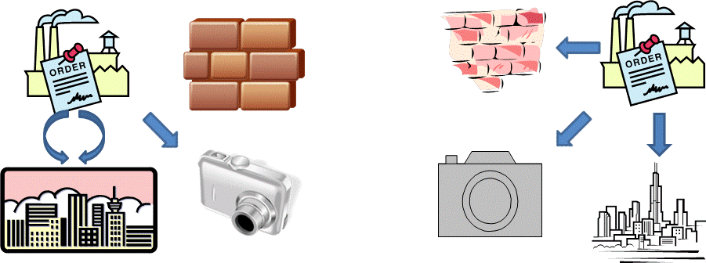

37. The main advantages that the introduction / implementation of the GSIM will offer the business in the medium term should be that:

- Production will be based upon more standardised applications that are more robust to change and less vulnerable to changing personnel.
- An increase in the use of standardised applications, which can easily be shared across domains, will enable the subject matter statisticians to more easily work in different domains.
- Rotation of subject matter statisticians and increased use of standardised components might increase the comparability of statistical products.
- Statisticians will gain greater control over the design of their processes making them more self-supporting and less dependent upon the information technologists and methodologists in the design and production of their statistics.
- The use of the GSIM and the GSBPM will ease the communication between business, methodologists and information technologists.

38. Using again the analogy with the production cycle, one factory can produce standardized building blocks from which again the final products of different complexity can be produced by statisticians. The situation is presented in the following picture.



39. From the business point of view it is not so easy to see the immediate advantages of the GSIM paradigm shift, but subject-matter statisticians need to be aware of the possibilities that can come from this shift.


VI. The methodology view

40. The concept of a fractal provides a useful metaphor for describing the creation of statistical production processes. A fractal has the characteristic that if one observes it at different levels of magnification one finds that its pattern is repeated at every level, in a recursive fashion. This holds also for the GSIM approach for designing statistical production processes. At each level we have to design the output and the input, and the process in-between. The output and the input can be designed in terms of structural and conceptual information objects, and the process in-between can be designed using the production information objects.

41. The first level of a fractal can be considered as equivalent to the statistical production process as a whole. The next level corresponds to a phase of the statistical production process (for example column 4, 5, 6 or 7 of the GSBPM). The third level of the fractal corresponds to a sub-process (for example sub-process 5.3 of the GSBPM – review, validate and edit). The fourth level consists of the individual building blocks within the sub-process. In some cases the third level may consist of only one building block.

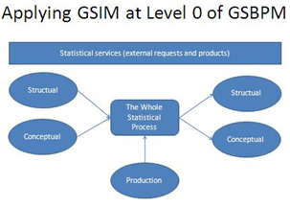 |   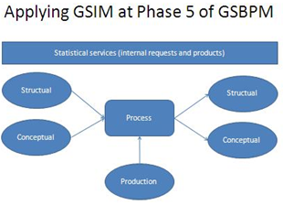
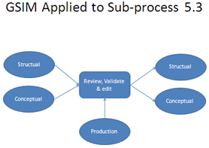 | 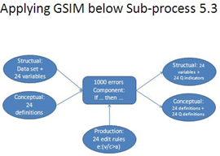

42. The GSIM facilitates the description of inputs and outputs at each level of the GSBPM, following the same pattern. It provides a consistent structure to design statistical processes.

43. This approach supports the idea of a grand unification model, bringing together the GSIM, the GSBPM, harmonised methods and standard technology to create a generalised statistical production system. It shows how the structural, conceptual and production information objects for the GSIM fit together with the structure of the GSBPM when applied in a re-design of statistical production processes. Statistical methods are applied via rules for both components and decision points. The components are implemented via technical solutions, and have standard interfaces for inputs and outputs in terms of their structural information objects.

VII. The information technology view

44. A main concern for information technologists is the duplication of effort due to the “stove-pipe” organisation of statistical production. Unstable and differing requirements from these “stove-pipes” lead to tailor made solutions, whilst a high turnover of IT staff can result in poorly documented and non-standard applications.

45. The introduction of the GSIM both at the national and at the international level can already bring short term benefits for information technology specialists. The GSIM will enable more flexible, independent and modular production systems.

46. At the national level, statisticians will become more self-supporting in the design (see the figure below) and production of their statistics. This will free the IT staff to make more robust applications and explore new ways to better meet the changing needs of the statistical organisation and the society at large.

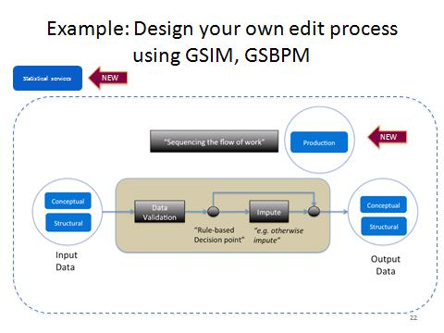

47. At the international level there will be increased possibilities for co-design and co-development of common components based upon more robust user-requirements from a wider user-community. The IT developers will also have access to a larger development community that all speak the same statistical and IT languages.

VIII. Links to other standards

48. Two key principles in the development of the GSIM were to re-use previous work wherever relevant, and to ensure that the GSIM integrates with other standards, and international initiatives. The question of how the GSIM relates to these other standards and models used by producers of official statistics is essential to its development and practical implementation.

- In regard to development, there is a clear message from the HLG-BAS that the GSIM cannot afford to “reinvent the wheel”. Other existing standards and frameworks have been developed through analysis of business requirements followed by practical testing and refinement. Where the resulting definitions and modelling constructs are fit for purpose they should reused by the GSIM.
- In regard to implementation, when producers come to apply the GSIM it is essential they can understand and apply it in the context of the standards and frameworks they already use.

49. Preparations for Sprint 1, and the early days of the sprint itself, had a focus on scanning the environment to identify other models/sources which were relevant to work on the GSIM. The group collectively reviewed a number of the most prominent examples (e.g. the GSBPM and the Common Reference Environment (CORE) project) before commencing the main design work on the GSIM. Relationships with standards such as Statistical Data and Metadata eXchange (SDMX) and the Data Documentation Initiative (DDI) were recognised as important considerations as well.

50. Many of these standards and frameworks address complementary aspects of the production process (e.g. the GSBPM for describing business processes, SDMX as a technical format for information exchange). Therefore it needs to be clear to implementers how the relevant complementary standards can be applied in a coherent and consistent manner to address their business needs.

51. The relationship of the GSBPM and the GSIM requires particular attention and explanation as these are the two conceptual cornerstones in the HLG-BAS vision for statistical production. It reflects the complementary relationship of business processes and the information which is:

- an input to them
- an output from them
- used to drive/control a process
- used to specify and control the flow of processes, including decision points in process flows

52. The proposed Grand Unification schema would elaborate on the nature of the partnership between the GSBPM and the GSIM.

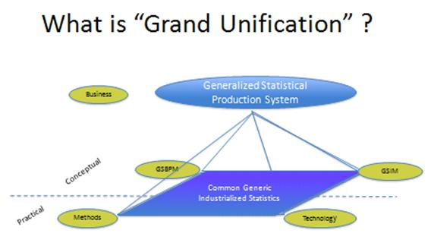

53. Existing models for statistical information were consulted extensively during design of the GSIM. These included the SDMX Metadata Common Vocabulary and related ontology work, Neuchâtel models, existing United Nations guidelines and the information models currently used by a number of national statistical organisations (e.g. Canada, New Zealand, Sweden and United Kingdom).

54. A useful (but not yet complete) starting point was Part B of the Common Metadata Framework, developed by the Conference of European Statisticians Steering Group on Statistical Metadata (METIS) which documents resources related to metadata concepts, standards, models and registries and possible relationships between the different resources. Work on the GSIM identified a number of extra sources that could be documented in Part B. Preliminary thoughts about how the GSIM relates to this existing “ecosystem” are shown in the following working diagram.

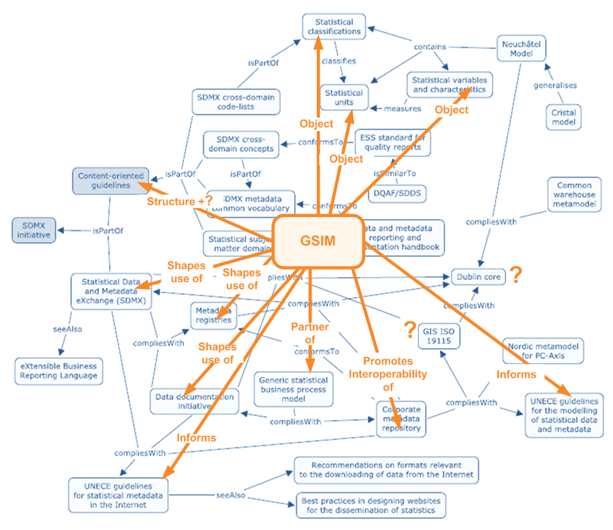

55. Technical standards such as SDMX and DDI are typically at a technical implementation level of detail that is not directly in scope within the GSIM. There is, however, great value if statistical organisations can harness these technical standards in a consistent, business driven manner based on an agreed “industry” formulation of how the GSIM might be applied in practice. Although such an agreed formulation would be an application of the GSIM, it would not form part of the definition of the GSIM itself.

56. The relationship of the GSIM with technical standards such as SDMX and DDI should be considered further. The starting point would be to relate the conceptual models underpinning SDMX and DDI to the GSIM (rather than the alternative of starting with the detailed technical XML implementation schemas underpinning SDMX and DDI).

57. The work of the CORE project is also recognised as likely to be highly relevant to those implementing the GSIM in detail. Many aspects of CORE can be seen as operating at a technical implementation level that should relate to GSIM in a defined manner. The main business process scenario that was used during design and testing of CORE has also been used as one of the use cases for testing the GSIM.

58. It appears that the CORE approach might be recommended as an important technical framework for implementing the Grand Unification approach.

Annex A. Definitions of the GSIM level 2 objects

Object | Definitions from published sources | Examples | Improved definition for GSIM (where necessary)
Statistical request | A statistical request is a request for a statistical product. | Needs, requirements
Business case | The business case argues the case for the project/work program proceeding. | Business case for providing or not providing certain statistical products.
Statistical product | The term output data or statistical products is used for all data, which are delivered by the statistical system. | Package of table, graph, text, anonymised microdata etc | Statistical products are all data which are delivered by the statistical system.
Statistical unit | Statistical unit types describe classes of objects that statistics relate to in different phases of statistical production. | Person, household, enterprise, event, hospital, fiscal unit, legal unit | Statistical units describe classes of objects that statistics relate to in different phases of statistical production.
Population | The total membership or population or "universe" of a defined class of people, objects or events. | Target population, survey population | All elements of a defined unit.
Variable | A variable is a characteristic of a unit being observed that may assume more than one of a set of values to which a numerical measure or a category from a classification can be assigned (e.g. income, age, weight, etc., and “occupation”, “industry”, “disease“ etc.) | Question, conceptual variable, contextual variable, quality indicator
Classification | A set of discrete, exhaustive and mutually exclusive observations, which can be assigned to one or more variables to be measured in the collation and/or presentation of data. | Value domain, code list

Data element | Unit of data for which the definition, identification, representation and permissible values are specified by means of a set of attributes | Observation record, administrative record
Data set | Any organised collection of data. | Data matrix | An organised collection of data on one type of unit.
Data series | A set of ordered observations on a quantitative characteristic of an individual or collective phenomenon taken at different points of time. | Time series, longitudinal data | An organised collection of data on one type of unit with a time dimension.
Composite data set | Data store where registered items are recorded and managed. | Business register | An organised collection of data with several linked unit types.
Component | A component is an identifiable part of the statistical production system. Usually, a component provides a particular function or a group of related functions. | Rule-based decision points, process controller, functional block (e.g. imputation)
Rule | A rule is an instruction that states the way things are or should be done. | Edit rule, process rule
Schedule | A schedule is a list of planned activities or things to be done showing the times or dates when they are intended to happen or be done. | Time table, validity period

Annex B. Information objects identified from previous initiatives

Table 1. Information objects in the Statistical Services Group

Level 1 | Level 2 | Objects from Sources | Sources
STATISTICAL SERVICES | INFORMATION  REQUEST | INFORMATION REQUEST | SPRINT
 | BUSINESS CASE | BUSINESS CASE | SPRINT
 | STATISTICAL  PRODUCT | STATISTICAL PRODUCT | SPRINT

Table 2. Information objects in the Conceptual Group

Level 1 | Level 2 | Objects from Sources | Sources
CONCEPTUAL | STATISTICAL UNIT | AGGREGATED UNIT | Multiple
 |  | MICRO UNIT | Multiple
 |  | STATISTICAL UNIT | Multiple
 | POPULATION | SAMPLE | Multiple
 |  | SAMPLING FRAME | Multiple
 |  | SURVEY POPULATION | Multiple
 |  | TARGET POPULATION | Multiple
 | VARIABLE | CONCEPT | Multiple
 |  | CONCEPTUAL VARIABLE | Multiple
 |  | CONTEXTUAL VARIABLE | Multiple
 | CLASSIFICATION | CLASSIFICATION FAMILY | SNZ
 |  | CLASSIFICATION | Multiple
 |  | CLASSIFICATION STRUCTURE | ONS
 |  | CLASSIFICATION LEVEL | SNZ
 |  | CLASSIFICATION CATEGORY | SNZ
 |  | CODELIST | Multiple
 |  | CODE (VALUE DOMAIN ITEM) | SSB
 |  | VALUE DOMAIN ITEM | SNZ
 |  | VALUE DOMAIN | Multiple
 |  | DOMAIN OF A VARIABLE | NET
 |  | CORRESPONDENCE TABLE | COSMOS
 |  | CONCORDANCE | SNZ
 |  | CONCEPTUAL DOMAIN | SNZ
 |  | CLASSIFICATION CORRELATOR | ONS
Note: Terminology related to classifications to be taken from the Neuchâtel Terminology Model for
classifications (version 2.1)

Table 3. Information objects in the Structural Group

Level 1 | Level 2 | Objects from Sources | Sources
STRUCTURAL | DATA ELEMENT | ADMIN RECORD | CMR
 |  | DATA ELEMENT | SNZ
 |  | DATA ITEM | SNZ
 |  | DATA RECORD | OCM
 |  | MEASURE | MCV ONT
 |  | MEASUREMENT | CMR
 |  | OBSERVATION | UNp7
 |  | OBSERVATION RECORD | NET
 |  | OBSERVATION VALUE | MCV ONT
 |  | UNIT DATA RECORD | OCM
 | DATASET | ARCHIVE FILE DESCRIPTION | SSB
 |  | CUBE | NEUC-V
 |  | CUBE DESCRIPTION | SSB
 |  | CUBE RESPRESENTATION (MACRODATA) | NET
 |  | CUBE RESPRESENTATION (POP) | NET
 |  | DATA COLLECTION (DESC) | SNZ
 |  | DATA COLLECTION (FILE) | NEUC-V
 |  | DATA FILE, FINAL/INTERMEDIATE | OCM
 |  | DATA SELECTION | OCM
 |  | DATASET | Multiple
 |  | DATASET (DESC) | ONS
 |  | DATASET DEFINITION | CORE
 |  | DATASET DEFINITION | ONS
 |  | DATASET KIND | CORE
 |  | DERIVED STAT DATA | MCV ONT
 |  | ESTIMATE | MCV ONT
 |  | FINAL OBSERVATION REGISTER | NEUC-V
 |  | FRAME DESIGN | CAN
 |  | HYPERCUBE | NET
 |  | MACRODATA (DESC) | MCV ONT
 |  | MATRIX | NEUC-V
 |  | MICRODATA (DESC) | MCV ONT
 |  | MICRODATA REPRESENTATION | NET
 |  | STATISTICAL AGGREGATE | OCM
 |  | STATISTICAL TABLE | COSSI
 |  | SURVEY INSTANCE | CMR
 |  | TABLE | Multiple
 |  | TABLE (DESC) | UNp7
 |  | TABLE CLASSIFICATION | ONS
 |  | TABLE DESCRIPTION | SSB
 |  | TABLE POPULATION | NET

 | COMPOSITE DATASET | REGISTRY | MCV ONT
 |  | REGISTER | Multiple
 | TIME SERIES | CASE (WAVE) | ONS
 |  | DATA COLLECTION SERIES | SNZ
 |  | LONGITUDINAL DATA | SSB
 |  | SERIES LAYER | NET
 |  | STUDY SERIES | SNZ
 |  | SURVEY WAVES | CAN
 |  | TIME SERIES | ONS

Table 4. Information objects in the Production Group

Level 1 | Level 2 | Objects from Sources | Sources
PRODUCTION | COMPONENT | BUILDING BLOCK DESCRIPTION | SPRINT
 |  | CONTROL | SPRINT
 |  | REFERENCE | SPRINT
 |  | INPUT | SPRINT
 |  | OUTPUT | SPRINT
 |  | SUB-BLOCKS | SPRINT
 | RULE | CONTROL RULE (EDIT CHECK) | COD1
 |  | EDIT/IMPUTE/CONFIDENTIALITY  RULE | OCM
 |  | ERROR (DETECTION) | OCM
 |  | FORMULA | OCM
 |  | PROCESS RULE | COD1
 |  | RULE | OCM
 |  | TRIGGER | SPRINT
 | SCHEDULE | REFERENCE PERIOD | COD1
 |  | STATISTICAL ACTIVITY CYCLE | ONS
 |  | TIME FRAME | CMR
 |  | TIMETABLE (STATISTICAL  CALENDAR) | ONS
 |  | VALIDITY PERIOD | SPRINT
 |  | EVENT | Multiple

Table 5. Key to the sources used to identify information objects for bottom up modelling

CAN | Statistics Canada
CMR | Corporate Metadata Repository (CMR) Model, Presentation by Dan Gillman
COD1 | CODACMOS, Final Deliverable 6.2 – Report on the “common” core model in  data collection and on the definition of level of standardisation
COD2 | CODACMOS, Appendix 1 - Metadata items description
CORE | ESSnet COmmon Reference Environment, Final Deliverable 2.2 CORE  Information Model, Pages 17 - 21
COSMOS | COSMOS, Deliverable 4 – Common Core Metadata Conceptual Model and  Object Model
COSSI | Common Structure of Statistical Information, Version 0.91, Statistics Finland
INE | Statistics Portugal's Case Study, METIS April 2008
MCV ONT | Metadata Common Vocabulary – Ontology, Deliverable 3
Multiple | A number of sources listed mentioned the same object
NET | Statistical Metadata Tutorial by Wilfried Grossmann
NEUC-V | Neuchâtel Terminology Model for variables (version 1.0), Figures only
OCM | OCMIMF GSIM, V0.1
ONS | Office for National Statistics, Statistical Domain Model, UK
OQRM | Object-oriented Quality and Risk Management Model, P.W.M van Nederpelt
SNZ | Statistics New Zealand
SPRINT | Objects identified during Sprint 1
SSB | Statistics Norway
UNp7 | UN Guidelines for the modelling of statistical data and metadata, 1995

Annex C. Case studies of applying the GSIM in practice

Three business process-based use cases were used during Sprint 1 to test early versions of the design of Level 1 and Level 2 of the GSIM model.

The main purposes of the testing were to identify whether:

- Anything appeared to be missing from the groups and categories (Level 1 and 2) identified in the early design
- Anything should be clarified regarding the scope and definition of the existing groups/categories
- Any of the existing groups/categories appeared to be redundant as they were not required in practical use cases

Having worked through the use cases, the results also provided (broad rather than detailed) examples of how GSIM might be applied in practice to describe/model common business processes.

While the use cases led to a couple of changes in the design of Level 1 and Level 2, the evaluation based on the use cases suggested the design was fundamentally robust and relevant to practical application.

Analysis of the use cases also helped to clarify and elaborate more specific information objects, which can be found within various categories at Level 3 of GSIM.

The three use cases are briefly documented below. They were

1. Questionnaire Design
2. Sample Allocation + Estimation
3. End to end (GSBPM Phase 1 to Phase 9) example of a register based census

These scenarios and the outcomes from their evaluation are described below.

Some points that arose from the use cases overall are

- Data Series is not mentioned in any of the use cases.
  - Use cases focused more specifically on analysis and dissemination would be likely to reference this category
  - More detailed analysis and description of some of the existing use cases might also include reference to this category
- Data Element is only mentioned in one of the use cases.
  - More detailed analysis and description of these other use cases would include reference to this category as it is a means of addressing specific content within a dataset. It may appear somewhat “mechanical” to keep referring to this category in, e.g. describing the relationship between variables and datasets.

Technical note

Within the use case analysis, terms in square brackets [ ] refer to categories at GSIM Level 2.

Use Case 1: Design a questionnaire

Notes

This Use Case addressed the “question of questions” (and related information objects) which had been raised by external practitioners and by Use Case 2.

This use case, developed a day later than the other two, contains the greatest level of elaboration on how GSIM might be applied in practice to the business process targeted by this scenario. Nevertheless, the Sprint Team recognised there are additional issues, and levels of detail, that an expert practitioner in questionnaire design would identify in working through the scenario.

The scenario starts with the theoretical target concepts that the designer of the statistical survey/activity has in their mind. The first step (described by Rule 1 below) is to determine how these “concepts in the mind of the designer” relate to instances of information objects (concepts belonging to the [Variable] category at GSIM Level 2) that have already been defined explicitly – or to add new instances of information objects (within the [Variable] category) if necessary.

Details

Rule 1:
Create or re-use an existing concept from the store of the [Composite data set] that contains a concept and its associated [(conceptual) Variable]. The relevant concept can be selected based on parameters for key uses incl. (statistical) domain and administrative status (e.g. approved, deprecated)

The [Composite data set] Concepts & Conceptual Variables store might look like this:

Concept | Concept Attribute 1 | … | Concept Attribute n | Associated  Conceptual  Variable

One concept has one and only one [(conceptual) Variable]

Rule 2:
Create or re-use an existing Question/Question Module from the [Composite data set/object] that contains Questions/Question Modules and their associated [(contextual) Variables]. Relevant Questions are selected based on the relevant [(conceptual) Variables] of Rule 1.

The [Composite data set] ‘Question Modules, Questions & Conceptual Variables store’ might look like this:

Question  Module | Associated  Questions | Question  text | Question  response domain | Conceptual  Variable  associated with the Question

One Question can be associated with several Question Modules.
A Question is associated with one and only one [(conceptual) Variable]

Rule 3:
Create a Questionnaire from the relevant Question Modules(s) and Questions of Rule 2 by using parameters for sequence and flow etc. This Questionnaire might undergo formal design approval at this stage, thereby changing its administrative status or undergo a repeat of rule 3.
Depending on the need to reuse Questionnaires these may be stored as electronic documents and/or in the appropriate format and archive of a Questionnaire Design tool.

Rule 4:
Create different Questionnaire Designs from the approved Questionnaire of Rule 3 by using different parameters for rules/guidelines for layout/collection mode. The Questionnaire Designs should then be assessed for fitness for use and if necessary undergo a re-design.

Use Case 2: Sample Allocation + Estimation

Notes

This use case was defined based on the CORE scenario for testing CORE environment. Slide 7 of the linked presentation provides a process flow diagram for the scenario overall. The benefits of selecting and testing this particular scenario have been well documented by the CORE team in their presentation.

By using the same scenario, it was anticipated that this example of testing GSIM might, in the future, be related to the results in testing of CORE. This, in turn, might be progressed to a single use case that illustrated how GSIM and CORE might be applied together. This would be one form of test for gaps, overlaps, ambiguities and inconsistencies between GSIM and CORE.

It is understood that in the CORE context the scenario was only applied to ALLOCATION and ESTIMATION. In the GSIM context it was tested on the full process flow shown on Slide 7, and a few elements of Phase 1 (Specify Needs) and Phase 7 (Disseminate) of GSBPM were also considered.

Details

Identify business need
- Subpopulation of interest [Population]
- User requirement [Information request]
Compute Strata Statistics + Allocate the sample (2.4 Design Frame and Methodology)
- Existing Resources [Dataset]
- Classification [Classification]
- Population [Population]
- Parameters – e.g. expected response rate, quality requirement (RSE) : Parameter is a component of [Rule]
- Register [Composite dataset]
- Rule/Formulae [Rule]
- Statistical Unit [Statistical unit]
- Variable [Variable]
- Sample Frame under [Dataset]
- Sampling size calculation [Rule]
Select the Sample (4.1 Select Sample)
- Sample Frame under [Dataset]
- Statistical Unit [Statistical unit]
- Sample Design [Rule]
- Rules [Rule]
- Sample Frame under [Dataset]
Collect Survey Data
- Questionnaire and Question See Use Case 1 – Questionnaire Design
- Statistical Unit [Statistical unit]
- Dataset [Dataset]
- Paradata – variable/dataset [Variable]/[Dataset]
- Rules –contact with respondent [Rule]
- Collection Mode See Use Case 1 – Questionnaire Design
- Other respondent information [Dataset]
- Validation rules [Rule]
Check and correct survey data
- Validation rules/edit rules [Rule]
- Dataset [Dataset]
- Data Item under [Data element]
- Method description – e.g. imputation [Rule]
- Parameters - a component of [Rule]
- Quality indicator e.g. which variable needed to be corrected for which unit variable/dataset [Variable]/[Dataset]
Calibrate survey data + Compute estimates and sampling errors (5.6 + 5.7 Calculate weights and calculate aggregates)
- Variable – auxiliary, micro and macro [Variable]
- Population [Population]
- Dataset [Dataset]
- Rules [Rule]
- Weights (variable -> [Variable])
- Sample design [Rule]
- Quality measure – variable/dataset [Variable]/[Dataset]
- Subpopulations [Populations]
Store Estimates and sampling errors
- Dataset [Dataset]
- Data structure design [Dataset]
Convert to SDMX
- Statistical output [Dataset]
- Technical function [Component]
- ESMS (Euro SDMX Metadata Structure) [Statistical product]

Other Issues

Wherever possible rules should be specified at design time (e.g. parameter values that might be supplied and what each value would mean) then applied during implementation. The exact details of how a rule was applied (e.g. the actual value of the parameter supplied during execution) should also be recorded at “run time”.

Use Case 3: Register Based Census

Notes

This use case was particularly based on the Slovenian experience with a register based census.

It was chosen in contrast to Use Case 2 because it focuses on the use of administrative sources rather than a sample survey, and the “assembly” of products from existing data sources rather than traditional “manufacturing” of products by collecting “new” data (raw material).

This scenario focused on all nine phases of the statistical business process as described by the GSBPM, although consideration of the last two phases (Archive and Evaluate) was abbreviated.

Identifiers such as “1.1/1.2” below refer to sub-processes in GSBPM. Where a particular sub-process had been considered extensively in Use Case 2, it was typically not considered in detail for Use Case 3.

Details

Specify Needs

1.1/1.2
- Regulations / Statutory Requirements (Environment->Info Request) [Information request]
- Stakeholder / Community Needs (Environment->Info Request) [Information request]

1.5
- Searching for sources (e.g. 5-7 years to put all together, may need one or two new registers – real-estate register)
  - existing sources [Data set], [Composite data set]
    - check external data sources can be accessed/used (legally)
    - memorandum of understanding, contract, agreement for a specific data source
      - considered to be in the corporate environment i.e. not a separate information object.
  - new data sets and composite data sets [Data set] [Composite data set]
  - quality criteria [Rule]
  - quality assessment of sources. An internal quality report might be structured as a text base [Dataset] or might simply be reference metadata attached to a particular information object. The reference might be to a document in an archive.
    - includes consideration of identifiers / “integratability”

1.6
- Resources / Business Case [Business case]

Design

2.1
- Define outputs
  - final dataset(s) [Dataset]
  - statistical products [Statistical product]

2.2 + 2.5
- Define variables (source, output, intermediate)
  - [Dataset] [Composite dataset]
  - [Variable]
  - rules [Rule]
    - for combining variables from multiple sources
    - integration
    - edits

2.4
- Establish target population
  - [Population]
    - reference day is part of [Population], but later in the process it could be in [Schedule]
  - [Statistical unit]
    - may be multiple types

2.6
Design overall process
- Components [Component]
- Schedule (e.g. timetable) [Schedule]
- Rules [Rule]
  - includes
    - processing rules (e.g. exception handling) / flow rules
    - methodological/statistical rules
- workflow/sequencing [Schedule]

3.3-3.5
- Tests inform refinement of designs (phase 2)
  - Test results may be kept as data [Dataset], [Composite dataset]

4.2 Set up collection

4.3 Run Collection
- Transmission process [Component]
  - Frequency of receipt [Schedule], revision [Rule], form of transmission in [Component

5
As per Use Case 2, except where mentioned below

5.1
- [Composite dataset]
- Rules [Rule]
  - priority of alternate sources
  - record linkage rules
  - quality criteria
- classifications [Classification]
- [Variable]
  - specifically identifiers

5.5
- Derive new units (eg households, families)
  - [Statistical unit]
  - composite datasets [Composite dataset]
  - rules [Rule]
- Derive new variables
  - [Variable]
  - [Rule]

6.4
- Disclosure control
  - Rules [Rule]
  - [Data element], [Dataset], [Composite dataset]
    - micro/macro
  - [Statistical unit]
  - variables [Variable]
  - [Data element]

7.2 Produce dissemination products
- Graphs, tables, commentary, methodological explanation, quality report, footnotes, presentation formats, data dictionary , classification (eg standard occupation classification)
  - [Statistical Product]
  - Rules [Rule]
    - e.g. publishing standards
  - Transformed data that underpins analysis, graphs etc
    - [Dataset]

7.3
- Release Time
  - [Rule]
  - [Schedule]
- Website destination
  - Under [Statistical Product]
- Press Release
  - [Statistical Product]
- Notification/dispatch to subscribers
  - Stakeholders will be part [Information request], subscribers will be part of [Statistical product]
- Discovery metadata can be part of a [Classification] and a component e.g. search engine.

7.4
- Promotional material
- Press conference

Record use of products as a process metric

8
- [Dataset]
- [Rule]

9
An internal quality report might be structured as a text base [Dataset] or it might simply be reference metadata attached to a particular information object. The reference might be to a document in an archive.

See: http://www1.unece.org/stat/platform/display/metis/GSIM+Common+Reference+Model
See: http://www1.unece.org/stat/platform/display/hlgbas/Strategic+vision+of+the+High-level+group+for+strategic+developments+in+business+architecture+in+statistics
See: http://www1.unece.org/stat/platform/display/metis/The+Generic+Statistical+Business+Process+Model

